
COLLEGE OF SCIENCE AND TECHNOLOGY
DEPARTMENT OF COMPUTER AND SOFTWARE ENGINEERING

STUDENT MANAGEMENT SYSTEM
Java Desktop Application using Swing and MySQL
Course: Object Oriented Programming in Java
Level: Year 2
Instructor: Ukulikiyeyesu Dieudonne

Submitted by:
- Hubert Nshuti Ngendahayo, 2240006525
- Happy Radouce Imbabazi, 224005053

Date: March 26, 2026

1. Introduction
This project is a desktop-based Student Management System (SMS) developed using Java Swing. The system allows users to manage student records through a graphical interface, including adding, updating, deleting, and searching student information.
The system also includes a login feature and is connected to a MySQL database for storing data persistently.

2. System Overview
The system has two main parts:
- Login Page (Authentication)
- Dashboard (Student Management)

3. System Flow
The system starts with login authentication. After successful login, the user accesses the dashboard to perform operations such as adding, updating, deleting, and searching student records.

4. Login Interface
The login interface allows users to enter their username and password to access the system.
It is designed with a split layout:
- Left side: branding (logo + system name)
- Right side: login form
Features:
- Username and password fields
- Remember Me checkbox
- Login button
- Clear button

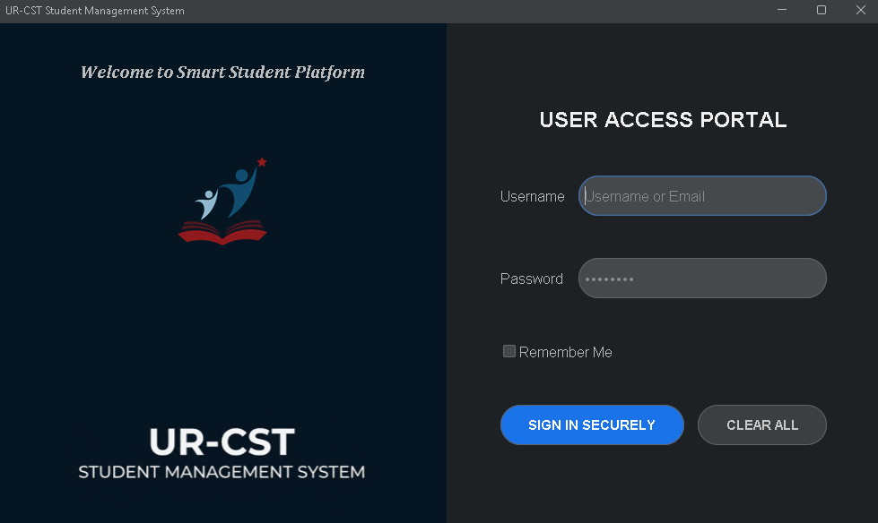

5. Dashboard Interface
After login, the user is taken to the dashboard where all operations are performed.
The dashboard is divided into two sections:
Left Side:
- Input fields (Name, Email, Course, Marks)
- Buttons (Add, Update, Delete, Search, Show All)
- Filter and sorting options

Right Side:
- Table displaying student records

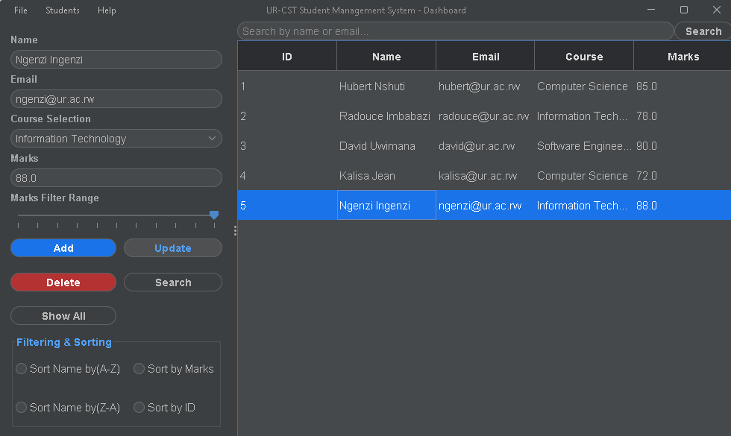

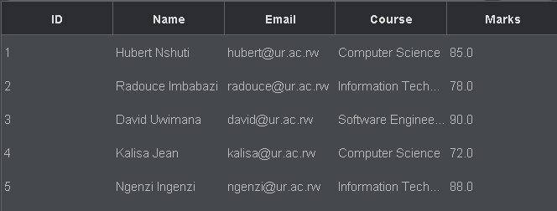
6. Menu Bar
A menu bar is included at the top of the dashboard for navigation.
Menus:
- File (Logout, Exit)
- Students (CRUD shortcuts)
- Help (About)

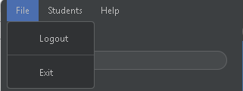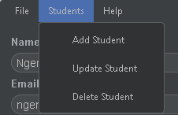
7. Database Integration (MySQL)
The system uses MySQL as the database to store all data.
Two tables are used:
- students
- users

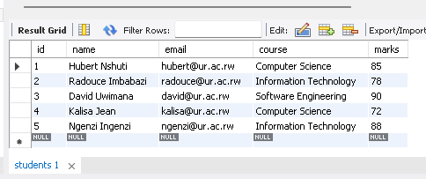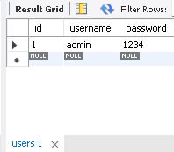
Fig… Screenshoots from MySQL Workbench

Table Structure
Students Table:
- id (Primary Key)
- name
- email
- course
- marks
Users Table:
- id (Primary Key)
- username
- password

8. CRUD Operations
The system supports all basic database operations:
Add Student
- User enters data and clicks Add
Update Student
- Select a row → modify → click Update
Delete Student
- Select a row → click Delete
Search Student
- Enter keyword → click Search

9. Validation
The system includes basic validation:
- Empty fields are not allowed
- Email must be unique
- Marks must be numeric
Buttons are enabled/disabled depending on input.

10. Database Connection
The system connects to MySQL using JDBC.
Connection is handled in a separate class:
- DBConnection.java
This ensures that all database operations use a single connection method.

11. Data Seeding
To make testing easier, some data is added automatically:
- Default user (for login)
- Sample students
This allows the system to run without manual setup.

12. Technologies Used
- Java (Core)
- Java Swing (GUI)
- MySQL (Database)
- JDBC (Database connection)
- FlatLaf (UI styling)
- Git & GitHub (Version control)

13. GitHub Repository
Project source code is available here:
https://github.com/hubertnshuti/Student-Management-System.git

14. Conclusion
This project demonstrates how a desktop application can be connected to a database to manage data effectively.
It combines GUI design, database interaction, and programming logic into one system.

END OF REPORT

